1. 
2. Agenda:
   1. How to configure Kafka Consumer App so that it recovers from deserialization error.
3. 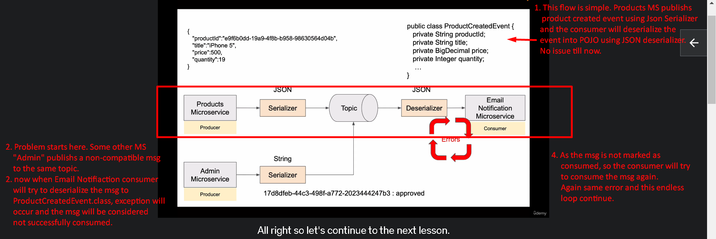
4. **NOTE**: Jatin -> Retry is performed only after msg marshalling is done successfully and exception occurs later on.   
   In next lecture, we will see how configure Consumer MS “Email Notification” to recover from such situations.